**Reading – Part A Waves in Matter**

The waves in the picture above are examples of **mechanical waves**. A **mechanical waves** is a disturbance in matter that transfers [energy](https://www.ck12.org/c/physical-science/energy?referrer=crossref) through the matter. A **mechanical waves** starts when matter is disturbed. A source of energy is needed to disturb matter and start a mechanical wave.

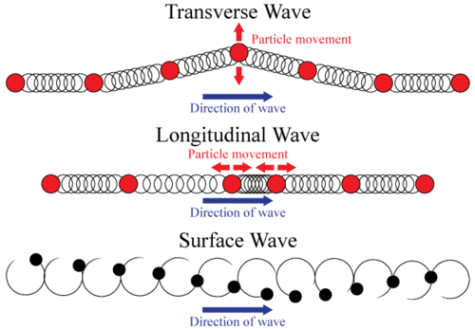There are two main types of waves – **longitudinal waves** and **transverse waves**.

In **longitudinal waves**, the vibrations of the medium are in the ***same direction*** as the wave motion. A physical example is a [sound wave](https://www.ck12.org/c/physical-science/sound-wave?referrer=crossref). For [sound waves](https://www.ck12.org/c/physics/sound-waves?referrer=crossref), high and low pressure zones move both forward and backward as the wave moves through them.

In **transverse waves**, the vibrations of the medium are ***perpendicular*** to the direction of motion. A classic example is a wave created in a long rope: the wave travels from one end of the rope to the other, but the actual rope moves up and down, and not from left to right as the wave does.

In **surface wave**, particles of the medium vibrate both up and down and back and forth, so they end up moving in a circle. A surface wave is **combination** of a **transverse wave** and a **longitudinal wave**.

**Reading – Part B Properties of Waves**

The **period**, T, is the amount of time for the wave to repeat itself, or for the object to go one full cycle. The period of a wave depends on the period of oscillation of the object creating the wave.

The **frequency,** f, is the number of cycles an object or wave goes through in 1 second. Frequency is measured in Hertz (Hz). 1 Hz = 1 cycle per sec.

The **amplitude,** A, is the [distance](https://www.ck12.org/c/physical-science/distance?referrer=crossref) from the *equilibrium* (or center) point of motion to either its lowest or highest point (end points). The amplitude, therefore, is half of the total [distance](https://www.ck12.org/c/physical-science/distance?referrer=crossref) covered by the oscillating object. The amplitude of a wave often determines its strength or intensity; the exact meaning of "strength" depends on the type of wave. For example, a [sound wave](https://www.ck12.org/c/physical-science/sound-wave?referrer=crossref) with a large amplitude is a loud sound and a light wave with a large amplitude is very bright.

A **medium(plural media)** is the substance through which the wave travels. For example, [water](https://www.ck12.org/c/biology/water?referrer=crossref) acts as the medium for ocean waves, while air molecules act as the medium for [sound waves](https://www.ck12.org/c/physics/sound-waves?referrer=crossref). When a wave passes through a medium, the medium is only temporarily disturbed. When an ocean wave travels from one side of the Mediterranean Sea to the other, no actual water molecules move this great [*distance*](https://www.ck12.org/c/physical-science/distance?referrer=crossref). Only the *disturbance* propagates (moves) through the medium. An object oscillating with **frequency** ***f*** will create waves which oscillate with the same **frequency *f***. The [**speed**](https://www.ck12.org/c/physical-science/speed?referrer=crossref)***v*** and[**wavelength**](https://www.ck12.org/c/physical-science/wavelength?referrer=crossref) **λ** of a wave depend on the nature of the medium through which the wave travels.

**Transverse waves**

Transverse waves vibrate the particles of a medium perpendicularly to the direction of wave travel to produce the features shown in Figure 1 below.

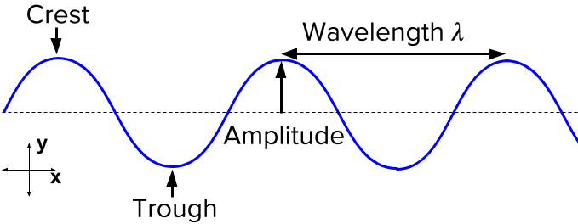

**Longitudinal waves**

Longitudinal waves form when the particles of the medium vibrate back and forth in the same direction of the traveling wave. The wave can be visualized as **compressions** and **expansions** travelling along the medium. The distance between adjacent compressions is the wavelength.